**Project code**

Kathryne Reed

Colorado State University Global

MIS581 Enterprise Performance Management

Professor Steve Chung

09/10/2023

Project Code

/* Generated Code (IMPORT) */

/* Source File: Tellurium Resources.xlsx */

/* Source Path: /home/u47562695/sasuser.v94 */

/* Code generated on: 9/9/23, 8:15 PM */

%web_drop_table(WORK.IMPORT);

FILENAME REFFILE '/home/u47562695/sasuser.v94/Tellurium Resources.xlsx';

PROC IMPORT DATAFILE=REFFILE

DBMS=XLSX

OUT=WORK.IMPORT;

GETNAMES=YES;

RUN;

PROC CONTENTS DATA=WORK.IMPORT; RUN;

%web_open_table(WORK.IMPORT);

/* Create a dataset with the weight of Tellurium */

data WeightData;

input Material $ Weight;

datalines;

tellurium 107.619111

;

run;

/* Specify the population mean for comparison */

%let PopulationMean = 1476179.62;

/* Specify the null hypothesis in the DATA step */

data WeightData;

set WeightData;

h0 = &PopulationMean;

run;

/* Perform the two-sample t-test */

proc ttest data=WeightData;

class Material;

var Weight;

title 'Two-Sample T-Test for Tellurium vs. Average Weight';

run;

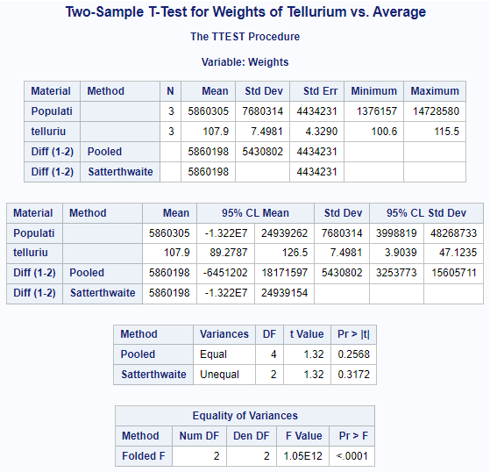

/* Create a dataset with grading values for Tellurium and Copper */

data GradingData;

input Material $ GradingValue;

datalines;

Tellurium 0.0412

Copper 0.447

Tellurium 0.033

Copper 0.076

Tellurium 0.156

Copper 0.392

;

run;

/* Perform a two-sample t-test */

proc ttest data=GradingData;

class Material;

var GradingValue;

title 'Two-Sample T-Test for Grading Values of Tellurium vs. Copper';

run;

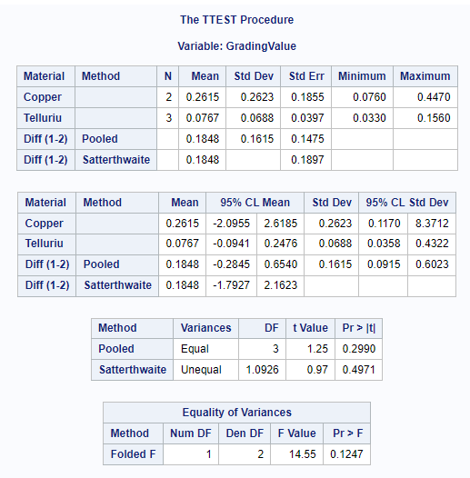

/* Create a dataset with age data for the Tellurium mine */

data MineAgeData;

input Age;

datalines;

92

91

93

91

92

94

;

run;

/* Set the null hypothesis mean */

%let NullMean = 70;

/* Perform a one-sample t-test */

proc ttest data=MineAgeData h0=&NullMean;

var Age;

title 'One-Sample T-Test for Average Age of Tellurium Mine';

run;

